**Module 3 Assignment 3: ERD Diagram**

**Haoze Zhang**

**Ira A. Fulton Schools of Engineering, Arizona State University**

**IFT 458/598: Middleware Programming & Database Security**

**Prof. Dinesh Sthapit**

**September 29, 2022**

**1: Requirements:**

Create a Basic ERD diagram that Relates a Student with the Courses and Student Contacts.

Export the ERD Diagram in PDF Format.

**Ans:**

**Github url:** [**https://github.com/zhzhaoze/IFT458-M3-A3-ERD-Diagram-Haoze-Zhang**](https://github.com/zhzhaoze/IFT458-M3-A3-ERD-Diagram-Haoze-Zhang)

**Entity:**

Student

Course

Student Contacts

**For student entity:** it has student_id (pk), student_name, student_address, student_gender, student_major

**For Course entity:** it has course_id (pk), course_name, course_professor, course_description, course_time, credits.

**For Student Contacts entity:** it has stu_contacts_id (pk), stu_contacts_name, stu_contacts_relationship, stu_contacts_phone_number, stu_contacts_address

**Relationship:**

**As for relationship between Student and Course:** Many students can take one course, also one student can take lots of courses, so it is many-to-many relationship.

**As for relationship between Student and Student contacts:** 2 or 3 students can have one contacts because these students may have been born in the same family. Also, one student can have many contacts such as his mother, father and other relatives. So it is many-to-many relationship.

**Lucid chart account:**

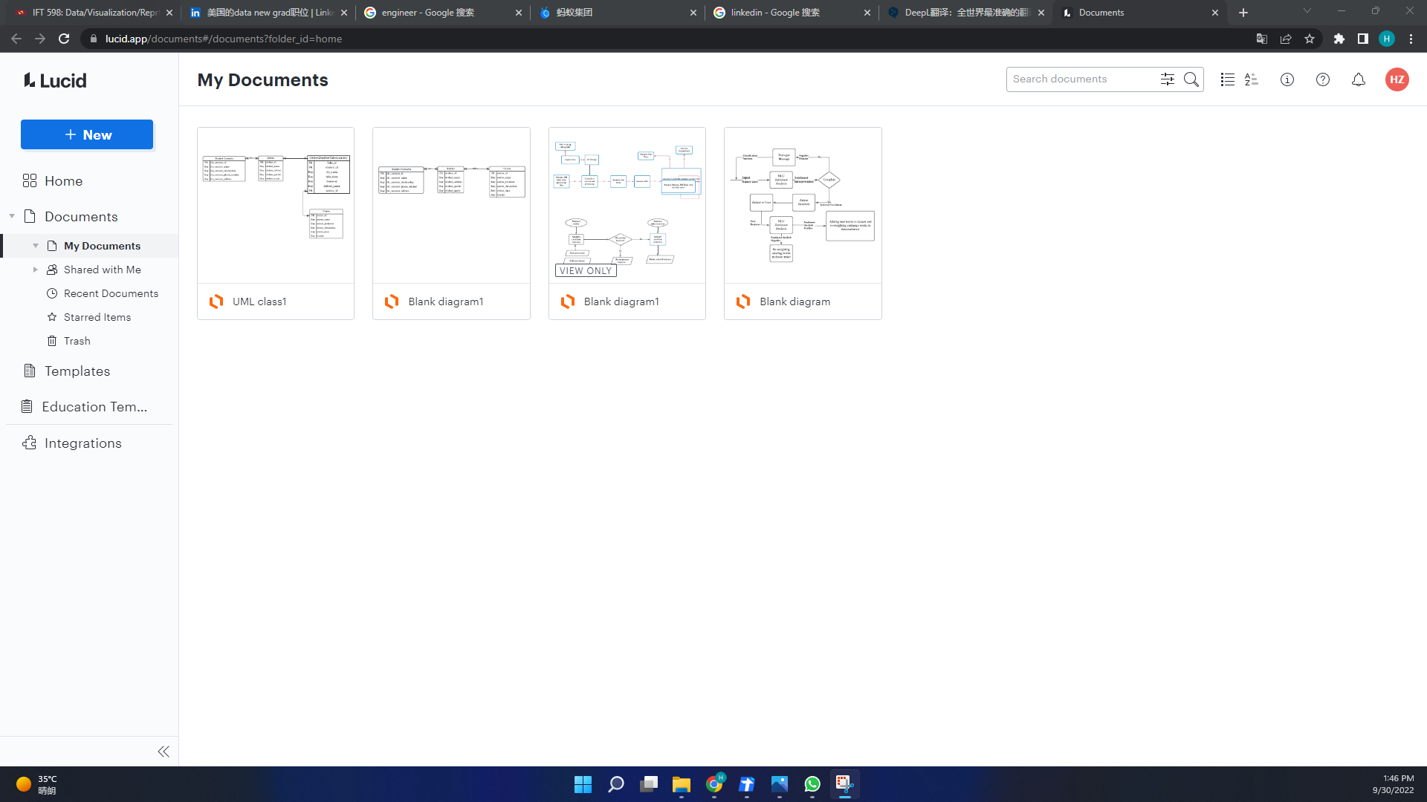

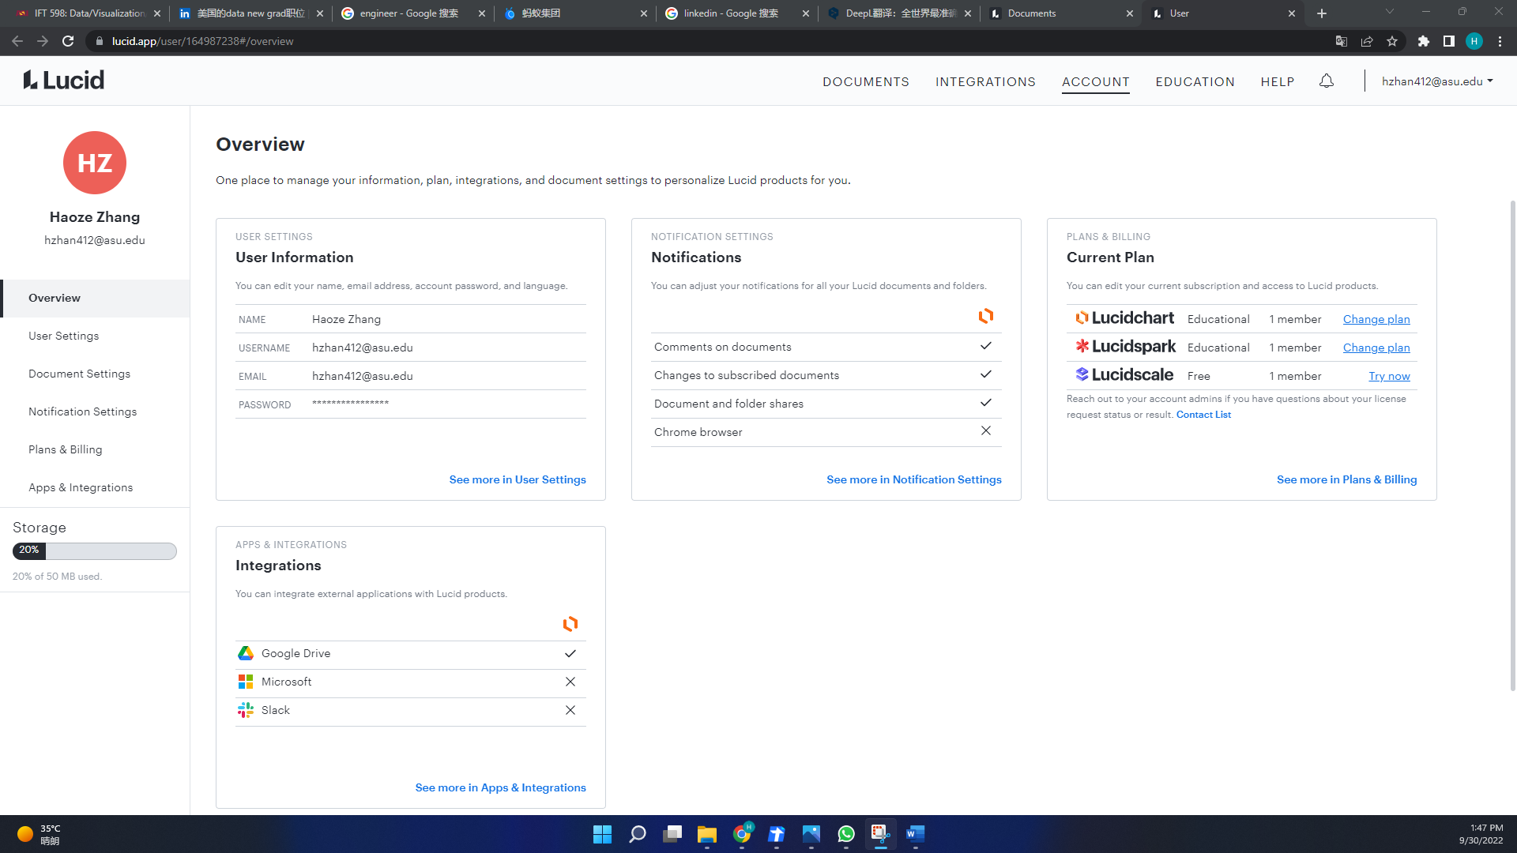

**The ERD Diagram is as followings:**



